Lattice Light Sheet Image Processing (Decurving)
Lattice light sheet microscopy uses thin sheets of light to illuminate the sample one slice at a time. This leads to an initial “skewed” image which must be deskewed prior to further computational processing. Prior to deskewing, a flatfield correction is done to correct for uneven illumination. There is also a step of deconvolution in which a point spread function is experimentally derived and used to deconvolve the image to increase contrast. The caveat to deconvolution is that in areas with good signal, the increase in sharpness is an advantage, but in regions with poor signal to noise ratio the deconvolution actually increases the sharpness in noise. In these instances using just the deskewed image should be sufficient for further processing and segmentation. The original, deskewed, and deconvolved images are saved as tiff volumes, where each volume is one time point containing all of the z layers.
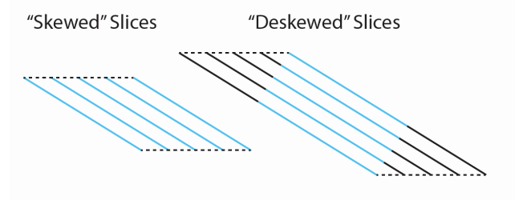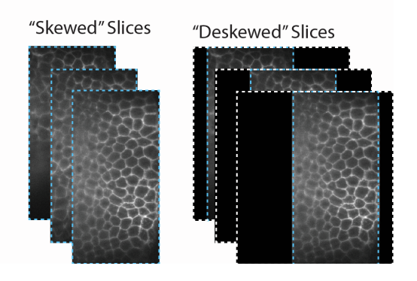
In this type of microscopy, embryos are suspended in fluid and have their natural curvature. To address this fact in light sheet data, the tissue depth surfaces are interpolated from whole image volume. The 3D coordinates where the first intense apical signal is present are identified. This can be done by manually selecting the most apical signal locations across a large sample of x-z and y-z image cross-section and collecting coordinates. This process can also be automated by adapting a 3D edge finding method to select the most apical edges across both x and y dimensions. These 3D coordinates are then used to fit a 2nd degree polynomial.
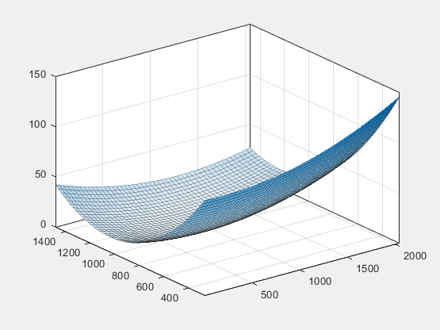
Once the fit has been determined, the whole volume is interpolated such that the apical surface is shifted at each pixel. This ensures that the apical surface for each cell is at the same z layer in the interpolated volume.
The stipulation with decurving is that the cells do not retain their original shape. Due to the process of shifting z pixels a shear deformation is created in the cells along the curved edge. Therefore, when calculating metrics such as cross sectional area, it is not the true cross section that is calculated, rather a diagonally and larger cross section not truly representative of the real value. One method to avoid this issue is to crop the decurved image to a region in which the majority of cells are vertical and have not been deformed much, but this significantly reduces the field of view and the available cells to use for downstream analysis.
To crop the decurved image appropriately, the angle between the normal vector and the vertical vector can be determined. Based on the resulting output, a threshold on maximum angle can be placed, and a bounding box around that region should encompass usable cells.

